Tutorial 4: Jump Pad

This is the final tutorial where I show you how to make a jump pad for the player to bounce up and down on and can be used to avoid laser etc.

1. 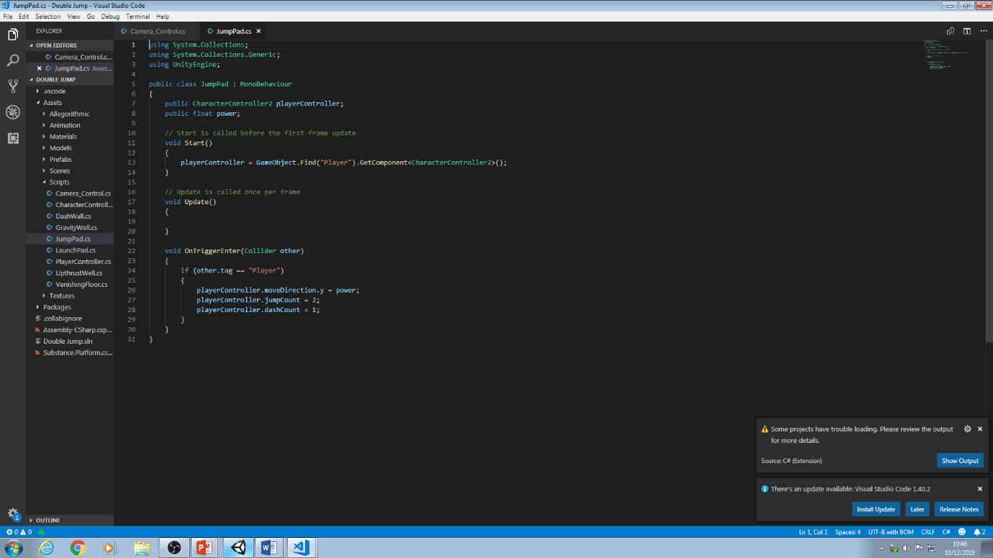Create a cube and call it JumpPad and then give it a box collider which is set to tigger. Also make the collider bigger on the top so the player enters it properly. Create a script on the cube and call it JumpPad.
2. First, create the variables shown in the picture
3. In the Start method reference the Player Controller script by typing playerController = GameObject.Find(“Player”).GetComponent<PlayerController>();
4. Create a new OnTriggerEnter(Collider other) and within that create a new IF statement with the condition other.tag == “Player”. In the IF statement type playerController.moveDirection.y = power; then playerController.jumpCount = 2; then finally playerController.dashCount = 1; this means that whenever the player enters the collider of the jump pad the power variable is applied to the the Y value of the moveDirection variable in the Player Controller causing the player to bounce up. The jump and dash count are reset so that if the player bounces they are able to still dash and jump whenever they want